dATFORM to GODATA INTEGRATION

Technical design

**VERSION** 1.00

**STATUS:** Draft

17-12-20

# table of CONTENTs

table of CONTENTs 2

Document SPECIFICATIONS 3

Revision History 3

Distribution 3

Reference Documents 4

1. PURPOSE 4

2. OVERVIEW 4

2.1 Infrastructure 4

2.2 Application Configurations 4

2.3 Application Security 5

User Authentication 5

2.4 Application Landscape 5

Project Management 5

Source Control/ Project Folders 5

Application 6

3. TECHNICAL IMPLEMENTATION 7

3.1 Access to Lime Survey 7

Process Flow 7

Lime Survey - Sessions 9

Lime Survey – Survey’s Answer 9

Lime Survey – Participant’s Info 10

3.2 Access to Go.Data 10

3.3 Log Files structure 12

4. DEPLOYMENT 13

APPENDIX A: ABBREVIATIONS 14

Abbreviations 14

Definition 14

# Document SPECIFICATIONS

## Revision History

This details the changes between versions:

|  |  |  |  |
| --- | --- | --- | --- |
| **Version** | **Date** | **Author (s)** | **Revision** |

|  |  |  |  |  |
| --- | --- | --- | --- | --- |
| 1.00 | 17/12/2020 | King | | Initial Draft |
|  |  |  | |  |
|  |  |  | |  |
|  |  |  | |  |
|  |  |  |  | |
|  |  |  |  | |
|  |  |  |  | |

## Distribution

This document has been distributed to:

|  |  |  |
| --- | --- | --- |
| **Name** | **Organization** | **Team** |
|  |  |  |
|  |  |  |
|  |  |  |
|  |  |  |
|  |  |  |

## Reference Documents

References may be made in this document to other documents. All such documents are referenced below:

# PURPOSE

This document describes the overall technical design for DataForm to GoData Integration. It is primarily intended for software developers and L4 support.

# OVERVIEW

This section of the document is an overview of the technical implementation of the DataForm to GoData Integration.

## Infrastructure

DataForm to GoData Integration is built using the following:

* .NET MVC
* .NET Framework 4.7.2
* Newtonsoft.Json 12.0.3
* Visual Studio installer projects

## Application Configurations

App.config

<add key="LogFolder" value="C:\Go.Data\synch\logs\" />

* Folder path. used to identity the folder location that profile images are stored. This should be outside the application. Files would be served by the application.

<add key="DataForm.RemoteControlURL" value="https://extranet.who.int/dataformv3/index.php/admin/remotecontrol" />

* Authentication is done by getting a session key with a user name and password and using the session key to make the Request.

<add key="LimeSurvey.UserName" value="Username is here" />

<add key="LimeSurvey.Password" value="Password is here" />

<add key="LimeSurvey.Id" value="Id is here" />

<!--LimeSurvey - method: export_responses-->

<add key="LimeSurvey.sDocumentType" value="json" />

<add key="LimeSurvey.sLanguageCode" value="" />

<add key="LimeSurvey.sCompletionStatus" value="complete" />

<add key="LimeSurvey.sHeadingType" value="code" />

<add key="LimeSurvey.sResponseType" value="short" />

<add key="LimeSurvey.iFromResponseID" value="85" />

<add key="LimeSurvey.iToResponseID" value="" />

* To retrieve Limesurvey id by range. This may tune up performance

<!--LimeSurvey - method: list_participants-->

<add key="LimeSurvey.iStart" value="0" />

<add key="LimeSurvey.iLimit" value="500" />

<add key="LimeSurvey.bUnused" value="" />

<add key="LimeSurvey.aAttributes" value="usesleft" />

<add key="LimeSurvey.aConditions" value="" />

<add key="GoData.UserName" value="Username is here" />

<add key="GoData.Password" value="Password is here" />

<add key="GoData.OutbreakID" value="OutbreakID is here" />

<add key="GoData.APIUrl" value="http://godata_shw.who.int/api/" />

* LoopBack API Explorer. Can use to validate Go.Data API

## Application Security

### User Authentication

No authentication is required as the console app will run by scheduler. This is without human interaction.

## Application Landscape

### Project Management

|  |  |  |
| --- | --- | --- |
| **Parameter** | **Value** | **Note** |
| Application Code |  |  |
| UAT Site |  |  |
| Production |  |  |

### Source Control/ Project Folders

* Source Control : Github
* URL : <https://github.com/WorldHealthOrganization/godata/>
* Latest source code folder :
* Latest documentation folder :

### Application

|  |  |  |
| --- | --- | --- |
| **Parameter** | **Value** | **Notes** |
| LSIntegration | .NET solution. Test/debugging layer. |  |
| JsonRPCclient | Model used to call lime survey |  |
| WindowApp | Console app to call .NET solution. |  |
| Setup | Create Setup/MSI installer |  |

# TECHNICAL IMPLEMENTATION

This section of the document describes the technical implementation of the DataForm to GoData Integration.

## Access to Lime Survey

LimeSurvey RemoteControl 2 is a XML-RPC/JSON-RPC based web service available in LimeSurvey 2.0 or more recent which offers **various** [**API functions**](https://api.limesurvey.org/classes/remotecontrol_handle.html).

Lime Survey RemoteControl2/ LSRC2 url as below: <https://extranet.who.int/dataformv3/index.php/admin/remotecontrol>

### Process Flow

* Get lime survey session key from lime survey with credential
* Use session key to call api “export_responses” for survey’s answer
* Decode the returned responses

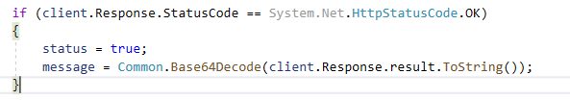

* Populate the message and deserialize the object. This will convert into readable List<> format in C#

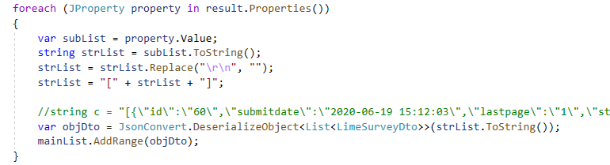

* Numbers of record retrieve from lime survey api can be customised by params (iFromResponseID/iToResponseID) in app.config.
* To avoid sending same limesurvey.id to go.data, console app will check against limesurvey.id in LimeSurvey_Master.txt.

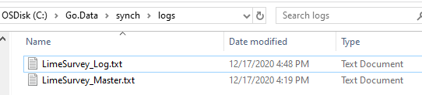

* + Program will call function below to validate. Returned true mean processed, should not proceed to post over go.data agin.

Common.IsSurveyIDExists(id);

* To indicate limesurvey’s api record belong to which contact, we have to tagged personId (unique id of Contact) from dataform.
  + Dataform URL: <https://extranet.who.int/dataformv3/index.php/admin>
  + Maintenance of personId will do via below screen

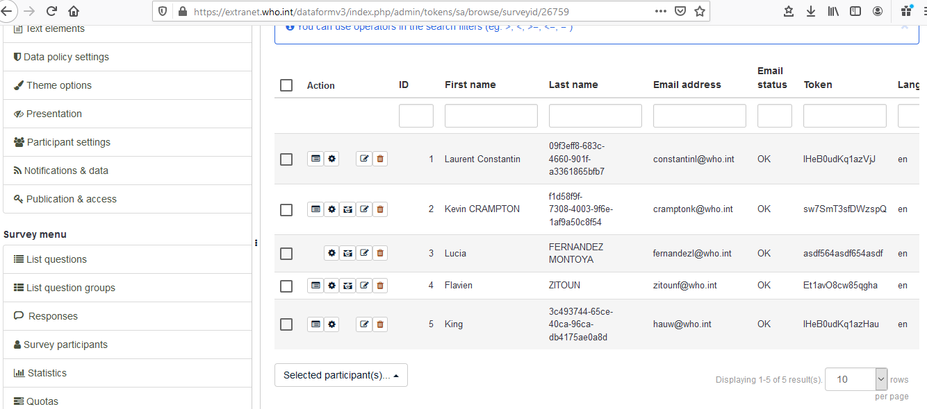

* + personId (obtain from go.data) must maintain into column of “Last Name”.
    - For future enhancement, should create new attribute of personId into list above
  + To get personId via limesurey api, call “list_participants” by using token provided in limesurvey’s record. For api detail, kindly refer to [Lime Survey – Participant’s Info] below.
    - string personId = dal.GetPersonIdByLSToken(lstoken);
* Once collected all the informations, do data mapping for limesurvey – go.data. Url reference as below.

<https://www.dropbox.com/s/254wxxj66j5mpyn/LimeSurvey%20to%20Go.Data%20Mapping.xls?dl=0>

* For data mapping, due to limesurvey not provide info for Fever(>38). CRAMPTON, Kevin has suggested business logic where temperature >=38 celsius, program will auto hardcode fever(>=38 celsius) == “Yes”

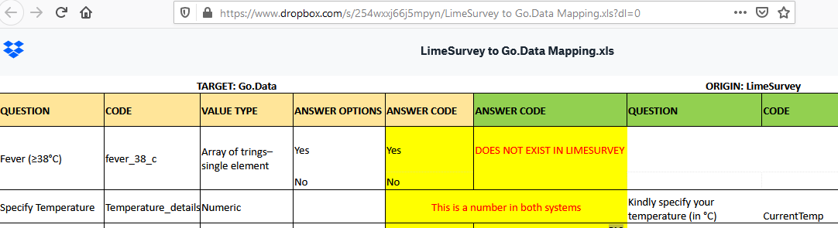

### Lime Survey - Sessions

API Name: get_session_key

Using this function you can create a new XML/JSON-RPC session key. This is mandatory for all following LSRC2 function calls.

**Parameter Description**  
username The username used for connexion  
password The password used for connexion   
Return on success: (string) session key.  
  
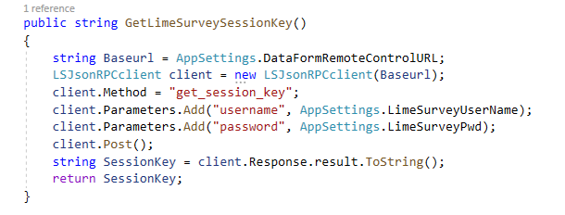

### Lime Survey – Survey’s Answer

LS API Name: export_responses

Export responses in base64 encoded string

**GET Survey answers**  
export_responses(string $sSessionKey,integer $iSurveyID,string $sDocumentType,string $sLanguageCode = null,string $sCompletionStatus = 'all',string $sHeadingType = 'code',string $sResponseType = 'short',integer $iFromResponseID = null,integer $iToResponseID = null,array $aFields = null): array|string

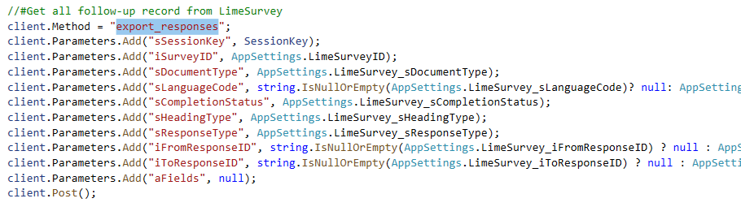

### Lime Survey – Participant’s Info

LS API Name: list_participants

Return the IDs and properties of survey participants (RPC function)

**GET Participants Info**  
list_participants(string $sSessionKey,integer $iSurveyID,integer $iStart,integer $iLimit = 10,boolean $bUnused = false,boolean|array $aAttributes = false,array $aConditions = array()): array

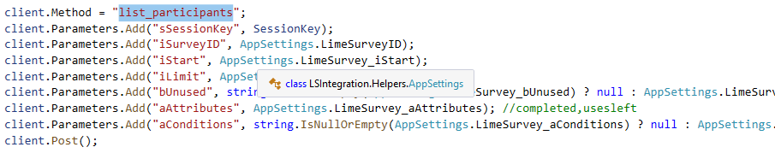

## Access to Go.Data

* API documentation can be found here: <http://godata_shw.who.int/explorer/>
* Authentication is by means of a token. Examples below
* Get the list of contacts from go.data
  + [GET](https://godata-r9.who.int/explorer/#!/outbreak/outbreak_prototype_findById_contacts) -----------<http://godata_shw.who.int/>api[/outbreaks/{id}/contacts](https://godata-r9.who.int/explorer/#!/outbreak/outbreak_prototype_findById_contacts)?access_token=xxxxxxxxxxx
  + The outbreak ID will be a fixed parameter, eg: f3924461-4604-4d0d-a9a1-bb7df532359c
  + Example to post to go.data
    - [Sample response object](https://www.dropbox.com/s/bczbnb3wyxcn7jy/Go.Data%20-%20Object_GET_contacts_example.json?dl=0)
    - <https://godata-r9.who.int/auth/login>
* Have to get go.data access_token before calling the rest of go.data api
  + From c#

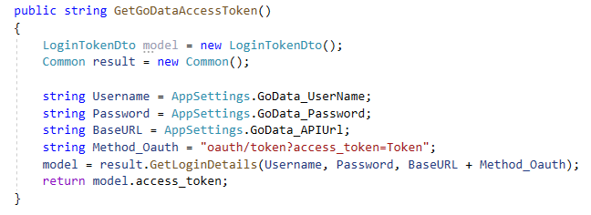

* + To try out via go.data api explorer, try out as below

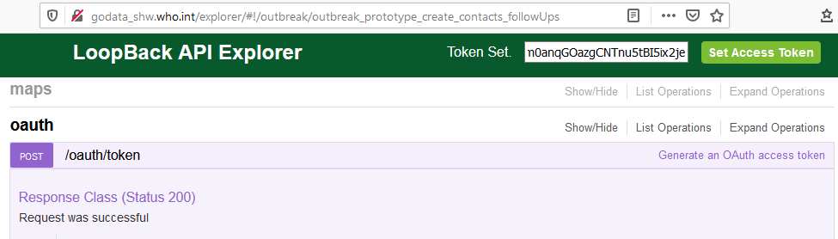  
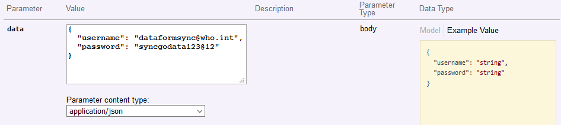

* Post follow-up to go.data
  + [POST](https://godata-r9.who.int/explorer/#!/outbreak/outbreak_prototype_create_contacts_followUps) ---------<http://godata_shw.who.int/>api[/outbreaks/{id}/contacts/{nk}/follow-ups](https://godata-r9.who.int/explorer/#!/outbreak/outbreak_prototype_create_contacts_followUps)?access_token=xxxxxxxxxxxxxxxx

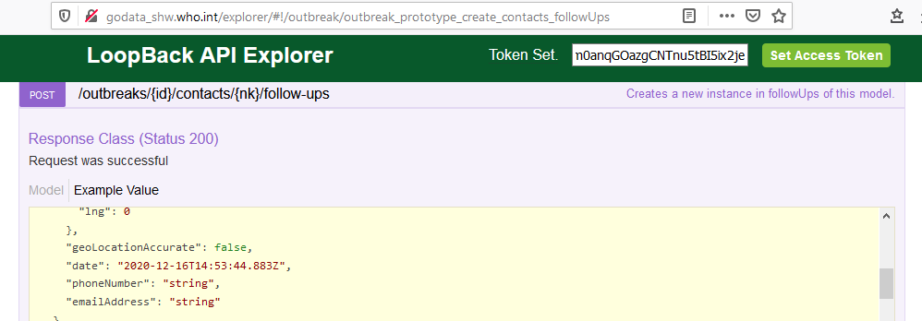

* Log success transferred to go.data into LimeSurvey_Master.txt/ LimeSurvey_Log.txt

## Log Files structure

Manual create logs folder at C:\Go.Data\synch\logs  
System will auto create new file if the text file not exists

|  |  |  |
| --- | --- | --- |
| **File Name** | **Purpose** | **Notes** |
| LimeSurvey_Master.txt | To store all record has been successfully sent over to go.data. |  |
| LimeSurvey_Log.txt | To record every execution with number of successfully records |  |

# DEPLOYMENT

* Create setup installation file in visual studio
* Build and deploy into msi package

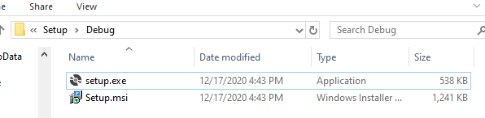

* Installation on SHW machine, scheduler will be set by CRAMPTON, Kevin

# APPENDIX A: ABBREVIATIONS

## Abbreviations

List of Abbreviations

|  |  |
| --- | --- |
| Abbreviation | Description |
| LS | Lime Survey |
| LSRC2 | Lime Survey RemoteControl2 |

## Definition

List of Definitions

|  |  |
| --- | --- |
| **Definition** | **Description** |
|  |  |
|  |  |
|  |  |
|  |  |